Making Tax Digital for Income Tax
A simple checklist for landlords and sole traders
From your accountant or agent

Making Tax Digital for Income Tax 1
1. Am I Affected? 2
2. What Will Change? 2
3. What You Will Need to Provide 3
4. Getting Set Up With Us 3
5. The Tool We Use 3
6. Frequently Asked Questions: 4
7. Final Step 4
Appendix A: Information you may be asked to provide 5
Client information sheet 6

As Making Tax Digital for Income Tax is introduced, many landlords and sole traders are confused about what this means for them. The good news is that the process does not need to be complicated. This simple checklist explains what may change, what you will need to provide, and how we will support you throughout your tax filing process.
This checklist explains:
- Whether the rules may apply to you
- What will change in the way taxes are reported
- What information may we need from you
- How we will help you stay compliant with HMRC

1. Am I Affected?
You are likely affected by Making Tax Digital for Income Tax if any of the following apply to you:

- You are self-employed
- You earn income from a UK property
- You earn income from foreign property
- Your total income from these sources exceeds the HMRC threshold.

If you are unsure whether this applies to you, your accountant or agent will help you check.

2. What Will Change?
Under Making Tax Digital, the way income is reported will become more frequent and structured. Instead of submitting one tax return at the end of the year, you will:

- Keep digital records of your income and expenses.
- Send quarterly updates to HMRC
- Submit a final declaration at the end of the tax year.

3. What You Will Need to Provide
To keep the process simple and efficient, we will need to following from you:

- Your HMRC login details, if not already authorised.
- A spreadsheet or digital record of your income and expenses.
- Your business details, if you are self-employed
- Your property details, if you are a landlord.
- Confirmation before each submission is sent

A detailed list of the information that may be required is provided in Appendix A at the end of this document.

4. Getting Set Up With Us
To prepare for Making Tax Digital, we will help you with the technical setup by:

- Connect our Agent Services Account to HMRC
- Add you to our secure AbraTax system (this is the software we are using to submit your records to HMRC)
- Confirm your reporting obligations
- Set up reminders for each quarterly submission.

You will receive email notifications whenever approval is required. You remain in control throughout the process, and nothing will be submitted to HMRC without your confirmation.

5. The Tool We Use
We use AbraTax to submit updates to HMRC securely and efficiently. This allows us to:

- Upload your spreadsheet totals directly
- Check figures for errors before submission.
- Send you a draft for approval.
- Store submission receipts and records
- Track quarterly and annual deadlines

You will only need to log in if we ask you to review and confirm a draft submission.
We manage the reporting process for you, and you simply review and confirm the information when prompted.

6. Frequently Asked Questions:
(This section can include common client questions about MTD in the future.)

7. Final Step

If you believe that Making Tax Digital applies to you, please reply to this form, and we will begin the setup process.
We aim to keep the process straightforward, organised, and fully compliant with HMRC requirements.

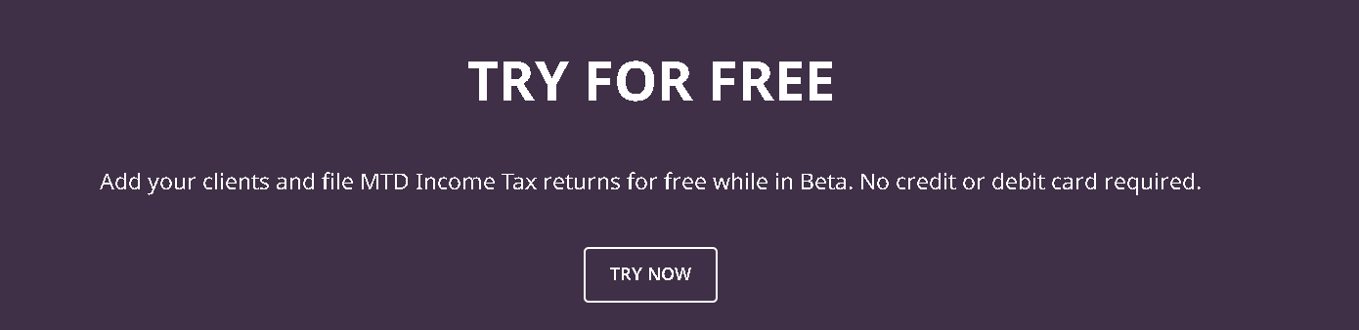
Information provided is for general guidance only and does not constitute tax advice.

Appendix A: Information you may be asked to provide
To help your accountant prepare your submissions, you may be asked to provide some of the following information.

If you are self-employed, you may be asked for:
• Business name
• Business address
• Description of your business activity
• Business start date
• Spreadsheet or digital records of income and expenses

If you receive UK rental income, you may be asked for:
• Property address
• Rental income received
• Expenses related to the property
Examples include repairs, mortgage interest, letting agent fees, and insurance.

If you receive foreign property income, you may be asked for:
• Country where the property is located
• Rental income received
• Property expenses
• Currency used

Client information sheet
Please complete the information below and return it to your accountant so the setup process can begin.

Client name:
Email address:
Phone number:

Income sources (tick any that apply):
- Self-employed business
- UK rental property
- Foreign rental property
If self-employed:
Business name:
Business activity:
Business start date:
If landlord:
Property address(es):

How do you currently keep records?
- Spreadsheet
- Accounting software
- Paper records
- Other

- I confirm that my accountant may submit quarterly updates to HMRC on my behalf once I approve the figures.

This checklist is created by AbraTax
This checklist is created by AbraTax

